System: PoliceLegacy
(Turn on Document Map in View menu to easily navigate this document)

Introduction
All commentary is entered in italics and is automatically removed during the application build process.

This application passes through hundreds of millions of records from old cases and uses proprietary technology (PowerIndexer) to extract objects of interest (names,addresses, phone numbers etc) from police reports and related unstructured text. These objects are then matched against current and unresolved cases for relevance.

Host: PcClient
The functional section of a specification starts with a Host statement.

Start.Process
OldSource = System.Source
Unattended = True
System.TotalRows = 0
System.IndexedRows = 0
>Source.Form

End of Start.Process

Source.Form
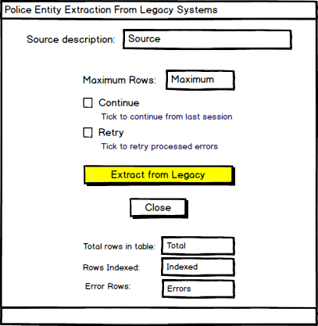
Source : System.Source
Maximum : System.Maximum
Continue : System.Resume
Retry : Edit
Total : System.TotalRows
Indexed : System.IndexedRows
Errors : System.ErrorCount

[Extract from Legacy] Error if System.Maximum <= 0 or System.Maximum > 1000000
-Heading = 'PowerIndexer'
-Message = 'Maximum Rows value is not valid'
System.Source = 'Legacy'
Legacy.Process runs extraction until session maximum is reached
Display -Heading = 'PowerIndexer'
-Message = 'Entity extraction completed.'
>End

[Close] >End

End of Source.Form

Legacy.Process
SaveLast = System.LastIndexed
System.LastIndexed = ' ' if System.Resume = False or Retry = True
System.RowCnt = 0
System.IndexedRows = 0
System.ErrorCount = 0
System.IndexStart = Now
System.TotalRows = SELECT COUNT(*) FROM Legacy
Refresh Form
Load Legacy if Retry = False Loading in batches of 1000 rows
Load Legacy for retry if Retry = True
For each Legacy
Create EntitySource
-SourceID = Legacy.AutoID
-TaskID = Legacy.Type
-InvestigationName = Legacy.SFNAME
-IndexDate = Nothing
-SourceName = System.Source
-SourceName = System.Source & ' - RETRY' if Retry = True
ContextId = Legacy.SFNAME sets context for powerindexer
Index Legacy.Narrative
If Legacy.ErrorMessage <> Nothing and Error = Nothing Clear old error message
>Legacy.ErrorMessage = Nothing
If Error <> Nothing
System.ErrorCount + 1
Legacy.ErrorMessage = Error
EntitySource.SourceName = EntitySource.SourceName & ' - ERROR'
System.LastIndexed = Legacy.AutoID
System.RowCnt + 1
EntitySource.IndexDate = Now shows that indexing has completed
Update System, EntitySource, Legacy to database
If System.RowCnt = 1000
System.IndexedRows + System.RowCnt
Load Legacy if System.IndexedRows < System.Maximum and Retry = False
Load Legacy for retry if System.IndexedRows < System.Maximum and Retry = True
System.RowCnt = 0
Refresh Form
Next Legacy
System.IndexedRows + System.RowCnt
System.IndexEnd = Now
Create SessionLog
-Source = System.Source
-LastIdIndexed = System.LastIndexed
-Resume = System.Resume
-Maximum = System.Maximum
-RowCnt = System.RowCnt
-IndexedRows = System.IndexedRows
-TotalRows = System.TotalRows
-IndexStart = System.IndexStart
-IndexEnd = System.IndexEnd
-ErrorCount = System.ErrorCount
>SessionLog.Source = SessionLog.Source & ' - RETRY' if Retry = True
>System.LastIndexed = SaveLast if Retry = True
End of Legacy.Process

Lexicon:
The lexicon is optional and managed by the project leader/facilitator. It enables easy-to-read phrases (left element) to be used in the specification. The right element contains the information that is used in the running application. The client would not generally be expected to review or approve this section.

Load Legacy for retry : SELECT TOP(1000) * FROM Legacy WHERE AutoID > [System.LastIndexed] AND
ErrorMessage IS NOT NULL AND ErrorMessage <> ''

End of Lexicon

Data Storage and Access:
This section is optional but commonly used. If you are using existing database tables you don’t need this section although it’s common to nominate the tables being used.

Any new database tables and/or columns would be discovered as a byproduct of the specification-only design process and could be automatically created directly or via generated scripts. This section would be managed by the project leader/facilitator..

DBMS:
Name: NSWpol
Type: SqlServer
Connection: Server=POLSQS22PI; Database=PowerIndexer; Trusted_Connection=True;

Legacy Table
Select Command: SELECT TOP(1000) * FROM Legacy WHERE AutoID > [ssSystem.LastIndexed]

EntitySource Table
SessionLog Table
SServant Table

System Table
Database Table = ssSystem
Select Command: SELECT * FROM ssSystem

Extracted Object classes from Powerindexer…
Person Table
Vehicle Table these tables are matched against current cases and used for further analysis
Location Table
OrgUnit Table
Event Table
Weapon Table
Telephone Table
Goods Table
Email Table
Url Table
Link Table

End of Host

End of Specification

